Task No. 02: Output of examples mentioned in the Lab.

Example No 01:

Solution:

using System;

namespace Abdullah_Sadiq

{

class Program

{

static void Main(string[] args)

{

Console.WriteLine("Hello World!");

}

}

}

Output:

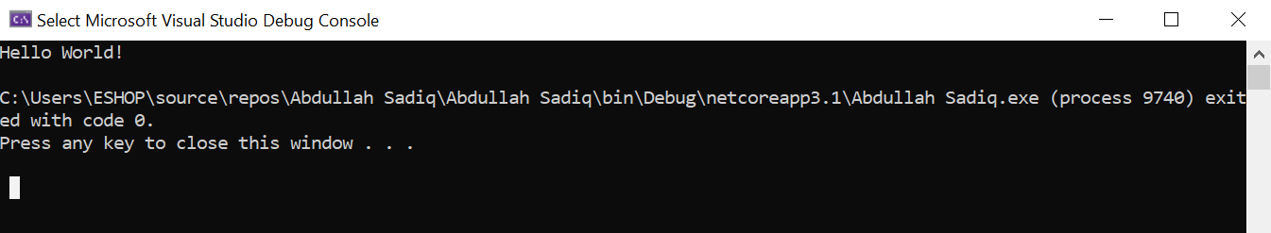

Example No 02:

Input:

using System;

namespace Example_no_02

{

class Program

{

static void Main(string[] args)

{

Console.WriteLine("Abdullah Sadiq");

Console.WriteLine("Age = 17");

Console.Write("Hobby = Photography ");

Console.Write("(Because I like it)");

}

}

}

Output: 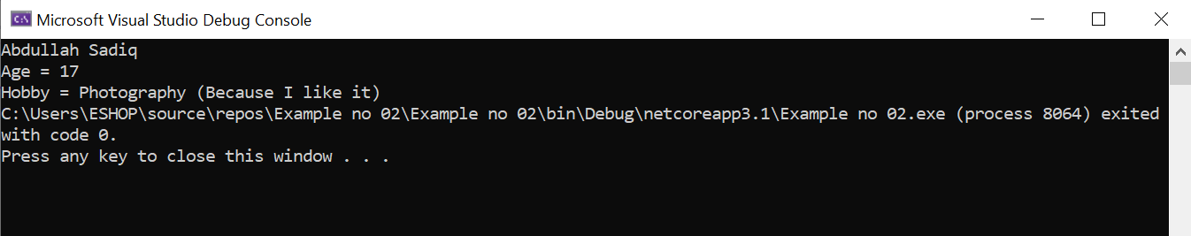

4